**AI ASSESSTED COADING**

*Assignment-13.3*

***Name****: V. Thriveni*

***Roll no****: 2403A52181*

*1)*

*2)*

3)

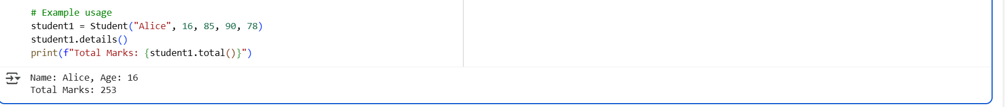

4)



